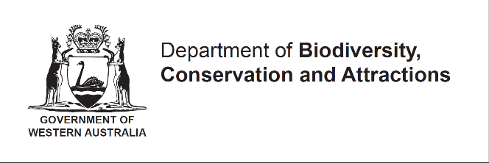
INJURED OR ABANDONED FAUNA NOTIFICATION
(Pursuant to Regulation 124 of the Biodiversity Conservation Regulations 2018)

This notification is for the possession of injured or abandoned fauna that is:
- Threatened fauna;
- Specially protected fauna; or
- Fauna specified in Schedule 6 (Biodiversity Conservation Regulations 2018).

This notification must be received within 24 hours after taking possession of the fauna.
Notification must be forwarded in writing to: wildlife.protection@dbca.wa.gov.au

Please complete ALL sections. Further information may be obtained from Wildlife Protection Branch via wildlife.protection@dbca.wa.gov.au, 9am – 5pm Monday to Sunday or via 9219 9840, 9am – 5pm Monday to Friday.
- Contact Information
First Name
Surname
Residential address
Phone Contact No.
Email
- Species Information
Species
Sex
Age (neonate, juvenile, sub-adult, adult)
Date found/taken into care and by who
Address/location where fauna was found
Reason for fauna being taken into care
(include details of injuries, diseases, mobility, abnormal behaviour etc.)
Address of where the fauna is being kept
Strategy for care and release

